Bimetallic Catalysis in Stereodivergent Synthesis
Wanbin Zhang*
School of Chemistry and Chemical Engineering, Shanghai Jiao Tong University
800 Dongchuan Road, Shanghai 200240, China
E-mail: wanbin@sjtu.edu.cn

Synergistic catalysis is gaining increasing attention due to its many advantages, such as improved catalytic activity, broad substrate scope, increased selectivity, and cost efficiency. Our research has focused on the development and application of synergistic catalysis for allylic substitutions. Several years ago, we have developed a concerted process using a Pd-catalyst, a pyrrolidine co-catalyst and a hydrogen-bonding solvent used for the allylic alkylation of simple ketones with allylic amines, allylic alkyl ethers and allylic alcohols.¹⁻² Very recently, we have successfully developed several bimetallic catalyst systems,³ which have been successfully applied for the first example of stereodivergent dual catalysis involving two metal catalysts.⁴ This strategy has proven to be efficient for the rapid and stereodivergent construction of important bioactive compounds bearing multiple stereocenters (Scheme 1).⁵⁻⁹
Bedaquiline bearing two stereocenters is the first FDA-approved drug against multidrug-resistant tuberculosis (TB) in the last half century, and its active ingredient is the unfavored stereoisomer, making its synthesis exceptionally challenging. Presently, the yield of the crucial step in the industrial production synthetic route is only 4%, resulting in a high production cost. Commissioned by the Bill & Melinda Gates Foundation, we has developed a Li/Li bimetal synergistic system for the efficient asymmetric synthesis of the antituberculosis drug Bedaquiline and its derivatives.¹⁰
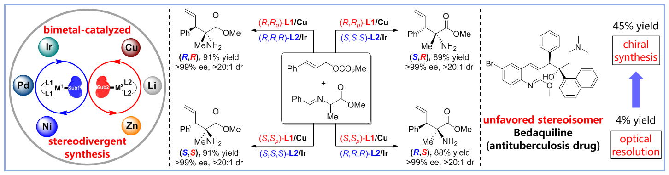
Scheme 1
References
1. X. Zhao, D. Liu, W. Zhang, J. Am. Chem. Soc. 2011, 133, 19354.
2. X. Huo, G. Yang, D. Liu, I. D. Gridnev, W. Zhang, Angew. Chem. Int. Ed. 2014, 53, 6776.
3. X. Huo, G. Li, X. Wang, W. Zhang, Angew. Chem. Int. Ed. 2022, 61, e202210086.
4. X. Huo, R. He, X. Zhang, W. Zhang, J. Am. Chem. Soc. 2016, 138, 11093-11096.
5. X. Huo, J. Zhang, J. Fu, R. He, W. Zhang, J. Am. Chem. Soc. 2018, 140, 2080-2084.
6. R. He, X. Huo, L. Zhao, F. Wang, L. Jiang, J. Liao, W. Zhang, J. Am. Chem. Soc. 2020, 142, 8097-8103.
7. J. Zhang, X. Huo, J. Xiao, L. Zhao, S. Ma, W. Zhang, J. Am. Chem. Soc. 2021, 143, 12622-12632.
8. Y. Luo, Y. Ma, G. Li, X. Huo, W. Zhang, Angew. Chem. Int. Ed. 2023, 62, e202313838.
9. J. Zhang, Y. Luo, E. Zheng, X. Huo, S. Ma, W. Zhang, J. Am. Chem. Soc. 2024, 146, 9241-9251.
10. F. Gao, J. Li, T. Ahmad, Y. Luo, Z. Zhang, Q. Yuan, X. Huo, T. Song, W. Zhang, Sci. China Chem. 2022, 65, 1968-1977.

