
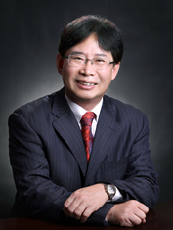
Wanbin Zhang

Professor
School of Chemistry and Chemical Engineering
Shanghai Jiao Tong University
800 Dongchuan Road, Shanghai 200240, P. R. China
Tel: +86-21-54743265
E-mail: wanbin@sjtu.edu.cn
Homepage: http://wanbin.sjtu.edu.cn/

Scientific Vita
2021-now Chair Professor, Shanghai Jiao Tong University
2013-2021 Distinguished Professor, Shanghai Jiao Tong University
2003-2013 Professor, Shanghai Jiao Tong University
2001-2003 Research Fellow, Mitsubishi Chemical Corporation, Japan
1997-2001 Assistant Professor, Osaka University, Japan
1997 PhD Applied Chemistry, Osaka University, Japan
1988 Master of Fine Chemistry, East China University of Science and Technology
1985 BS Chemistry, East China University of Science and Technology, Shanghai, China

Research Field
Organometallic chemistry, design of chiral catalysts, asymmetric catalysis, and pharmaceutical process chemistry.

Awards and Recognition
National Natural Science Award (2nd class, 2023), Shanghai Leading Talent Awards (2016), Shanghai Subject Chief Scientist Award (2014)

Representative Publications
- W. Zhu, C. Han, G. Yang, X. Huo, W. Zhang, Pd/Cu-Cocatalyzed Enantio- and Diastereodivergent Wacker-Type Dicarbofunctionalization of Unactivated Alkenes. J. Am. Chem. Soc. 2024, 146, DOI: 10.1021/jacs.4c06788.
- Z. Wu, J. Meng, H. Liu, Y. Li, X. Zhang, W. Zhang, Multisite programmable functionalization of alkenes via controllable alkene isomerization. Nat. Chem. 2023, 15, 988-997.
- M. Wang, Z. Zhang, W. Zhang, Design, Synthesis and Application of Chiral Bicyclic Imidazole Catalysts. Acc. Chem. Res. 2022, 55, 2708-2727.
- X. Huo, G. Li, X. Wang, W. Zhang, Bimetallic Catalysis in Stereodivergent Synthesis. Angew. Chem. Int. Ed. 2022, 61, e202210086.
- B. Li, J. Chen, D. Liu, I. D. Gridnev, W. Zhang, Nickel-catalysed asymmetric hydrogenation of oximes. Nat. Chem. 2022, 14, 920-927.

Bimetallic Catalysis in Stereodivergent Synthesis
Wanbin Zhang*
School of Chemistry and Chemical Engineering, Shanghai Jiao Tong University
800 Dongchuan Road, Shanghai 200240, China
E-mail: wanbin@sjtu.edu.cn

Synergistic catalysis is gaining increasing attention due to its many advantages, such as improved catalytic activity, broad substrate scope, increased selectivity, and cost efficiency. Our research has focused on the development and application of synergistic catalysis for allylic substitutions. Several years ago, we have developed a concerted process using a Pd-catalyst, a pyrrolidine co-catalyst and a hydrogen-bonding solvent used for the allylic alkylation of simple ketones with allylic amines, allylic alkyl ethers and allylic alcohols.¹⁻² Very recently, we have successfully developed several bimetallic catalyst systems,³ which have been successfully applied for the first example of stereodivergent dual catalysis involving two metal catalysts.⁴ This strategy has proven to be efficient for the rapid and stereodivergent construction of important bioactive compounds bearing multiple stereocenters (Scheme 1).⁵⁻⁹
Bedaquiline bearing two stereocenters is the first FDA-approved drug against multidrug-resistant tuberculosis (TB) in the last half century, and its active ingredient is the unfavored stereoisomer, making its synthesis exceptionally challenging. Presently, the yield of the crucial step in the industrial production synthetic route is only 4%, resulting in a high production cost. Commissioned by the Bill & Melinda Gates Foundation, we has developed a Li/Li bimetal synergistic system for the efficient asymmetric synthesis of the antituberculosis drug Bedaquiline and its derivatives.¹⁰
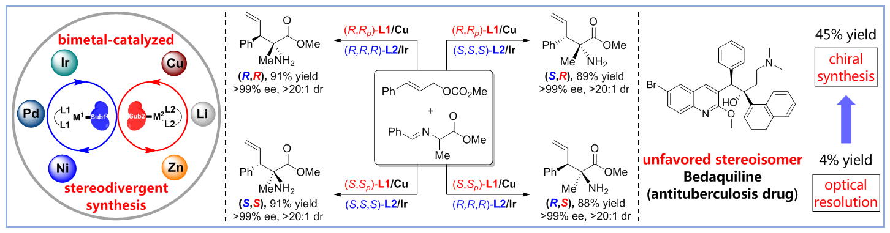
Scheme 1
References
1. X. Zhao, D. Liu, W. Zhang, J. Am. Chem. Soc. 2011, 133, 19354.
2. X. Huo, G. Yang, D. Liu, I. D. Gridnev, W. Zhang, Angew. Chem. Int. Ed. 2014, 53, 6776.
3. X. Huo, G. Li, X. Wang, W. Zhang, Angew. Chem. Int. Ed. 2022, 61, e202210086.
4. X. Huo, R. He, X. Zhang, W. Zhang, J. Am. Chem. Soc. 2016, 138, 11093-11096.
5. X. Huo, J. Zhang, J. Fu, R. He, W. Zhang, J. Am. Chem. Soc. 2018, 140, 2080-2084.
6. R. He, X. Huo, L. Zhao, F. Wang, L. Jiang, J. Liao, W. Zhang, J. Am. Chem. Soc. 2020, 142, 8097-8103.
7. J. Zhang, X. Huo, J. Xiao, L. Zhao, S. Ma, W. Zhang, J. Am. Chem. Soc. 2021, 143, 12622-12632.
8. Y. Luo, Y. Ma, G. Li, X. Huo, W. Zhang, Angew. Chem. Int. Ed. 2023, 62, e202313838.
9. J. Zhang, Y. Luo, E. Zheng, X. Huo, S. Ma, W. Zhang, J. Am. Chem. Soc. 2024, 146, 9241-9251.
10. F. Gao, J. Li, T. Ahmad, Y. Luo, Z. Zhang, Q. Yuan, X. Huo, T. Song, W. Zhang, Sci. China Chem. 2022, 65, 1968-1977.

